CakePHP 4 CRUD Tutorial with MySQL
by Sanjay Kumar
Table of Contents
- CakePHP 4.x Installation at System
- Application Database & It’s Configuration
- Settings Application Routes for CRUD Operations
- Application Models & Entity Settings
- Create Controller & CRUD Methods
- Creating View for Methods
Share this Article

Inside this article we will see about Basic CakePHP 4 CRUD Tutorial with MySQL (Create, Read, Update & Delete) Operations.
CRUD operation is a basic step of any computer programming. CRUD stands for the methods of Create, Read Update and Delete. So Inside this blog article we will see about the complete idea of insert upadte and delete in CakePHP 4.
If you want to perform CRUD operations in CakePHP 4, Here are the steps you need to follow. Let’s get started.

CakePHP 4.x Installation at System
Before installation of CakePHP we need some system requirements and it’s configuration. Here, System configuration means Server, PHP, Extensions, Database etc.
To know about basic installation settings to system, server to get this framework, you need to follow the guidelines of cakephp official document of. This document makes clear about what we need initially to set the things in a better way.
Additionally, we need composer at system. Composer is a tool which used to manage PHP dependencies, libraries etc .We will use composer to install CakePHP. So, first you need to install composer. If you have already installed or exists at your system, you can verify by command –
$ composer
If composer has been installed then this command will list all available commands of composer other wise you will get error something “composer command not found“.
Click here for the article – How to Install composer in ubuntu
Assuming Composer exists at system.
Let’s create a CakePHP project at system –
$ composer create-project --prefer-dist cakephp/app:~4.0 mycakephp
Above command will creates a project with the name called mycakephp.
Let’s get started about Database & Configuration.

Application Database & It’s Configuration
We need to create a database. Database table is going to store form data. We have created a database in PhpMyAdmin with the name of cakephp4_crud. You can choose your own custom name of database.
Either you can use Manual tool of MySQL or you can create via MySQL command.
CREATE DATABASE cakephp4_crud;
So, now we have a database. We need to create a table to store data. Let’s create a table with the name of tbl_students. This table again we can create via Manual interface of creating table or we can run a command to create it.
Create Table tbl_students –
CREATE TABLE IF NOT EXISTS tbl_students (
id int(10) unsigned NOT NULL AUTO_INCREMENT,
name varchar(120) COLLATE utf8_unicode_ci NOT NULL,
email varchar(120) COLLATE utf8_unicode_ci NOT NULL,
phone_no varchar(30) COLLATE utf8_unicode_ci NOT NULL,
PRIMARY KEY (id)
) ENGINE=InnoDB DEFAULT CHARSET=utf8 COLLATE=utf8_unicode_ci;
In table tbl_students we have columns as id, name, email & phone_no.
After creating database and table, now we need to configure and connect database with CakePHP 4 application.
Go to Project setup >> config (directory) >> app_local.php (file). Open this file to connect database.
Database
'Datasources' => [
'default' => [
'host' => 'localhost',
/*
* CakePHP will use the default DB port based on the driver selected
* MySQL on MAMP uses port 8889, MAMP users will want to uncomment
* the following line and set the port accordingly
*/
//'port' => 'non_standard_port_number',
​
'username' => 'root',
'password' => 'root',
​
'database' => 'cakephp4_crud',
/**
* If not using the default 'public' schema with the PostgreSQL driver
* set it here.
*/
//'schema' => 'myapp',
​
/**
* You can use a DSN string to set the entire configuration
*/
'url' => env('DATABASE_URL', null),
],
]
Successfully, we have now configured database connection with CakePHP 4 application.

Settings Application Routes for CRUD Operations
We need to create now application routes from where we can control the database operations like Create, Read, Update & Delete operations.
Go to Project Setup >> config (directory) >> routes.php (file). Open this file. We need to add CRUD routes in this file.
Routes
$routes->scope('/', function (RouteBuilder $builder) {
​
// Student Routes
$builder->connect('/add-student', ['controller' => 'Students', 'action' => 'addStudent']);
$builder->connect('/edit-student/:id', ['controller' => 'Students', 'action' => 'editStudent'], ["pass" => ["id"]]);
$builder->connect('/delete-student/:id', ['controller' => 'Students', 'action' => 'deleteStudent'], ["pass" => ["id"]]);
$builder->connect('/list-students', ['controller' => 'Students', 'action' => 'listStudents']);
​
});
Inside this routes configuration, we can see we have created routes for add, edit, delete & list. Next, we need to create Controller. Because all the actions what we have defined these are from Students Controller.

Application Models & Entity Settings
We need to configure Model & Entity. Model contains the information of Table where we will do crud operations. Entity define the columns for value assignment.
To create a model –
Go to Project Setup >> src (directory) >> Model (directory) >> Table (directory).
Inside Table directory, create a file StudentsTable.php. Inside this file copy and paste this given code.
StudentsTable.php
<?php
​
namespace App\Model\Table;
​
use Cake\ORM\Table;
​
class StudentsTable extends Table
{
public function initialize(array $config): void
{
$this->setTable("tbl_students");
}
}
Next, we need to set Entity for Table definition about value assignments.
To Create an Entity –
Go to Project Setup >> src (directory) >> Model (directory) >> Entity (directory).
Inside Table directory, create a file Student.php. Inside this file copy and paste this given code.
Student.php
<?php
​
namespace App\Model\Entity;
​
use Cake\ORM\Entity;
​
class Student extends Entity
{
protected $_accessible = [
"name" => true,
"email" => true,
"phone_no" => true
];
}
​

Create Controller & CRUD Methods
Controller is the file which controls the application flow. Inside this controller file we will create CRUD methods. Those methods handles create, read, delete & update methods.
To Create a Controller –
Go to Project Setup >> src (directory) >> Controller (directory)
StudentsController.php
<?php
​
namespace App\Controller;
​
use App\Controller\AppController;
​
class StudentsController extends AppController
{
public function initialize(): void
{
parent::initialize();

$this->loadModel("Students");
}
​
public function addStudent()
{
$student = $this->Students->newEmptyEntity();
if ($this->request->is('post')) {
$student = $this->Students->patchEntity($student, $this->request->getData());
if ($this->Students->save($student)) {
$this->Flash->success(__('The student has been created.'));
return $this->redirect(['action' => 'listStudents']);
}
$this->Flash->error(__('Failed to create student. Please, try again.'));
}
$this->set("title", "Add Stduent");
$this->set(compact("student"));
}
​
public function listStudents()
{
$students = $this->Students->find()->toList();
$this->set("title", "List Student");
$this->set(compact("students"));
}
​
public function editStudent($id = null)
{
$student = $this->Students->get($id, [
'contain' => [],
]);
if ($this->request->is(['patch', 'post', 'put'])) {
$student = $this->Students->patchEntity($student, $this->request->getData());
if ($this->Students->save($student)) {
$this->Flash->success(__('The student data has been updated successfully.'));
​
return $this->redirect(['action' => 'listStudents']);
}
$this->Flash->error(__('The student could not be updated. Please, try again.'));
}
$this->set(compact('student'));
$this->set("title", "Edit Student");
}
​
public function deleteStudent($id = null)
{
$this->request->allowMethod(['post', 'delete']);
$student = $this->Students->get($id);
if ($this->Students->delete($student)) {
$this->Flash->success(__('The student has been deleted.'));
} else {
$this->Flash->error(__('The student could not be deleted. Please, try again.'));
}
​
return $this->redirect(['action' => 'listStudents']);
}
}
​
Inside above code we can see addStudent, editStudent, deleteStudent, listStudents are the methods which handling CRUD functions. Keep in mind we have declared Model & Entity before creating this controller.
$this->loadModel(“Students”); This is loading Students model to controller.

Creating View for Methods
For crud methods like for add, edit, list we want the application view files. To create view files we will create a folder inside /templates directory.
Folder name – /templates/Students. Students is the name of the controller. We will keep all views inside this folder. Let’s create views for CRUD methods –
- addStudent – add_student.php
- editStudent – edit_student.php
- listStudents – list_students.php
These all views will be created inside /templates/Students/* directory.
add_student.php
<?= $this->Form->create($student, [
"id" => "frm-add-branch"
]) ?>
<div class="row custom-padding">
<div class="col-sm-6">
<!-- text input -->
<div class="form-group">
<label>Name</label>
<input type="text" required class="form-control" placeholder="Name" name="name">
</div>
</div>
<div class="col-sm-6">
<!-- text input -->
<div class="form-group">
<label>Email</label>
<input type="email" required class="form-control" placeholder="email" name="email">
</div>
</div>
</div>
<div class="row custom-padding">
<div class="col-sm-6">
<!-- text input -->
<div class="form-group">
<label>Phone No</label>
<input type="text" required class="form-control" placeholder="Phone No" name="phone_no">
</div>
</div>
</div>
​
​
<div class="row custom-padding">
<div class="col-sm-6">
<!-- Select multiple-->
<div class="form-group">
<button class="btn btn-primary">Submit</button>
</div>
</div>
</div>
<?= $this->Form->end() ?>
​
List view file –
list_students.php
<table id="tbl-students-list" class="table table-bordered table-striped">
<thead>
<tr>
<td colspan="5" align="right"><a href="<?= $this->Url->build('/add-student/', ['fullBase' => true]) ?>">Add Student</a></td>
</tr>
<tr>
<th>ID</th>
<th>Name</th>
<th>Email</th>
<th>Phone No</th>
<th>Action</th>
</tr>
</thead>
<tbody>
<?php
if (count($students) > 0) {
foreach ($students as $index => $data) {
?>
<tr>
<td><?= $data->id ?></td>
<td><?= $data->name ?></td>
<td><?= $data->email ?></td>
<td><?= $data->phone_no ?></td>
<td>
<form id="frm-delete-student-<?= $data->id ?>" action="<?= $this->Url->build('/delete-student/' . $data->id, ['fullBase' => false]) ?>" method="post"><input type="hidden" value="<?= $data->id ?>" name="id" /></form>
<a href="<?= $this->Url->build('/edit-student/' . $data->id, ['fullBase' => true]) ?>" class="btn btn-warning">Edit</a>
<a href="javascript:void(0)" onclick="if(confirm('Are you sure want to delete ?')){ $('#frm-delete-student-<?= $data->id ?>').submit() }" class="btn btn-danger">Delete</a>
</td>
</tr>
<?php
}
}
?>
</tbody>
</table>
Edit view file –
edit_student.php
<?= $this->Form->create($student, [
"id" => "frm-edit-branch"
]) ?>
<div class="row custom-padding">
<div class="col-sm-6">
<!-- text input -->
<div class="form-group">
<label>Name</label>
<input type="text" value="<?= $student->name ?>" required class="form-control" placeholder="Name" name="name">
</div>
</div>
<div class="col-sm-6">
<!-- text input -->
<div class="form-group">
<label>Email</label>
<input type="email" value="<?= $student->email ?>" required class="form-control" placeholder="email" name="email">
</div>
</div>
</div>
<div class="row custom-padding">
<div class="col-sm-6">
<!-- text input -->
<div class="form-group">
<label>Phone No</label>
<input type="text" value="<?= $student->phone_no ?>" required class="form-control" placeholder="Phone No" name="phone_no">
</div>
</div>
</div>
​
​
<div class="row custom-padding">
<div class="col-sm-6">
<!-- Select multiple-->
<div class="form-group">
<button class="btn btn-primary">Submit</button>
</div>
</div>
</div>
<?= $this->Form->end() ?>
​
Next, start development server
$ bin/cake server -p 8765
List Page URL: http://localhost:8765/list-students
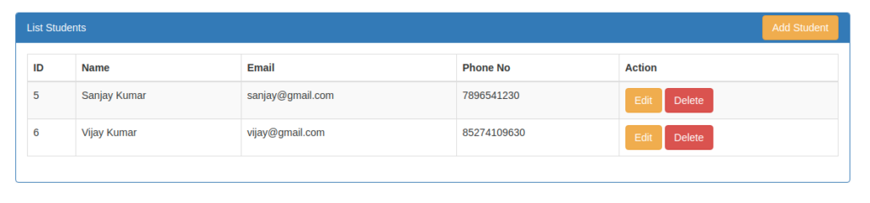
Add Page URL: http://localhost:8765/add-student
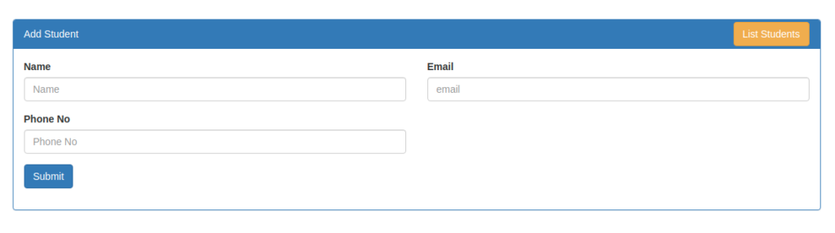
Edit Page URL: http://localhost:8765/edit-student/3
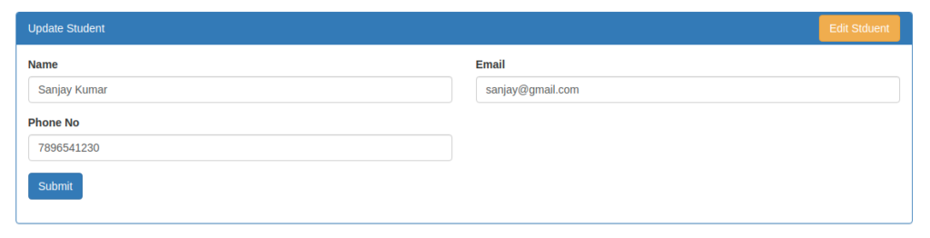
We hope this article helped you to learn about CakePHP 4 CRUD Tutorial with MySQL in a very detailed way.
If you liked this article, then please subscribe to our YouTube Channel for PHP & it’s framework, WordPress, Node Js video tutorials. You can also find us on Twitter and Facebook.

Sanjay Kumar
Hi, I am Sanjay the founder of ONLINE WEB TUTOR. I welcome you all guys here to join us. Here you can find the web development blog articles. You can add more skills in web development courses here.
I am a Web Developer, Motivator, Author & Blogger. I also used to take online classes including tech seminars over web development courses. We also handle our premium clients and delivered up to 50+ projects.

